**Interfacing Push Buttons to 8051 Using Polling**

**Lab #03**



Spring 2022

CSE-307L Microprocessor Based system Design

Submitted by: **Ashfaq Ahmad**

Registration No: **19PWCSE1795**

Class Section: **B**

“On my honor, as student of University of Engineering and Technology, I have neither given nor received unauthorized assistance on this academic work.”

Student Signature: ______________

Submitted to:

**Dr: Aber Irfan sab**

**July** 25, 2022

**Department of Computer Systems Engineering**

**University of Engineering and Technology, Peshawar**

**Task01:** Write a program having one button and 4 LEDs, when button is pressed then LEDs get turn off Using Polling.

**Source Code:**

#include <reg51.h>

#include <stdio.h>

sbit button=P1^0;

sbit led1=P2^1;

sbit led2=P2^2;

sbit led3=P2^3;

sbit led4=P2^4;

output=0x00;

void main(void)

{

    led1=led2=led3=led4=0;

    while(~button)   //polling

    {

            led1=1;

        led2=1;

            led3=1;

            led4=1;

    }

}#include <reg51.h>

#include <stdio.h>

sbit button=P1^0;

sbit led1=P2^1;

sbit led2=P2^2;

sbit led3=P2^3;

sbit led4=P2^4;

output=0x00;

void main(void)

{

    led1=led2=led3=led4=0;

    while(~button)   //polling

    {

            led1=1;

        led2=1;

            led3=1;

            led4=1;

    }

}

**Output:**

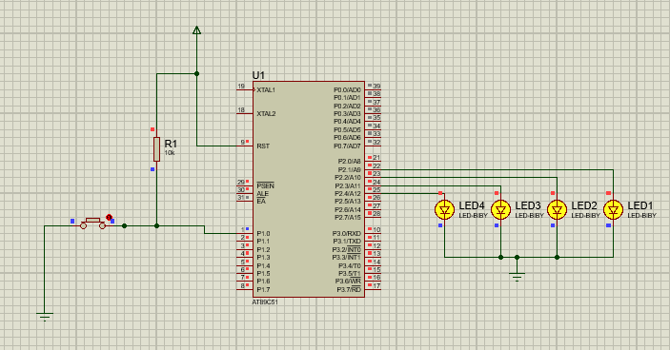

**Task 02:** Write a program having 2 inputs and 4 outputs and acts like 2x4 decoder.

**Source Code:**

#include <reg51.h>

#include <stdio.h>

sbit button1=P1^0;

sbit button2=P1^1;

sbit led1=P2^1;

sbit led2=P2^2;

sbit led3=P2^3;

sbit led4=P2^4;

void main(void)

{

    while(1)

    {

        if((button2==0) && (button1==0))   //polling

        {

            led1=1;

        led2=0;

            led3=0;

            led4=0;

        }

        if((button2==1) && (button1==0))   //polling

        {

            led1=0;

        led2=1;

            led3=0;

            led4=0;

        }

        if((button2==0) && (button1==1))

        {

            led1=0;

        led2=0;

            led3=1;

            led4=0;

        }

        if((button2==1) && (button1==1))

        {

            led1=0;

        led2=0;

            led3=0;

            led4=1;

        }

    }

}

**Output:**

